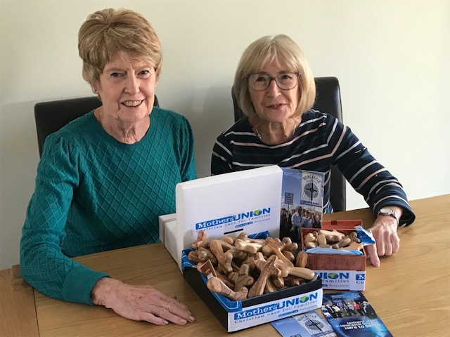

West Deanery decided to buy Handheld Crosses for the Hospital in thanks of the care that James, the husband of Leahan who looks after our Branches at Ven Bede West Road. James had a huge op on Boxing Day 2019 in the RVI and spent time in ITU and while in Hospital bought crosses for ITU.
The Branches decided that they would like to show our support and give thanks to the RVI. We were able to buy 93 handheld crosses and we gave them to the Chaplaincy Newcastle Hospitals for them to use in their work.
Anne Blight West Deanery Leader

