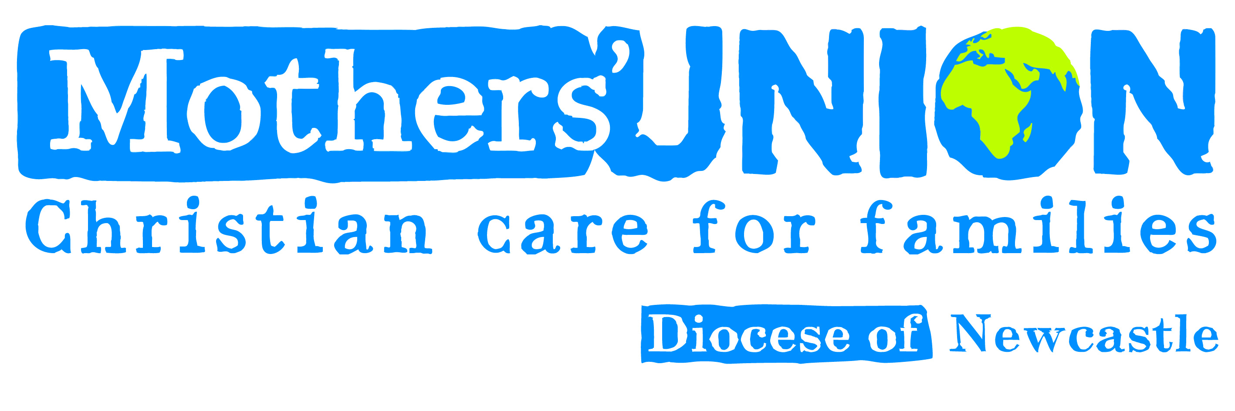

SAFEGUARDING REPORT OCTOBER 2021

There have been no safeguarding issues of concern reported in the Diocese.

Basic Safeguarding Training has been taken up by one or two members in almost every branch. Safeguarding information and advice from Mary Sumner House has been forwarded to Branch Leaders over the past few months, most recently with advice on returning to meeting together again.

There will be a small card attached to the next “Connected” magazine with concise advice about safeguarding.

Mothers’ Union follows the safeguarding policy of the local church. Branches need to liaise with their Parish Safeguarding Officer. If there are concerns where an MU activity is managed in the local church, these concerns should be reported in the first instance to the Parish Safeguarding Officer. However, any concerns relating to Mothers’ Union should also be reported to the MU Diocesan Safeguarding contact.

Should there be any questions about Safeguarding policies and procedures, risk assessments, or training please contact me.

Sheila

MU Diocesan Safeguarding contact
Sheila Walker
Email: sm59walker@gmail.com
Tel: 01434322369

Diocesan Safeguarding Adviser
Carol Butler
Email: c.butler@newcastle.anglican.org
Te: 07825167016

