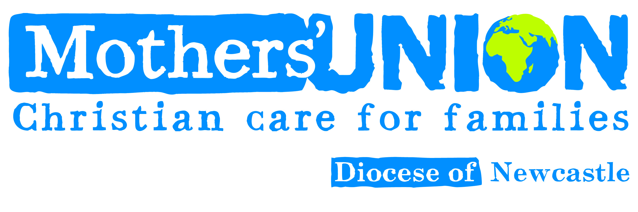

SAFEGUARDING

At a meeting in January 2021, the trustees asked me to be the safeguarding contact for Newcastle Diocese.

You will be aware that I have been encouraging the branches to have at least one member with Safeguarding training C0 and C1. I am pleased to say that the vast majority of branches have given me details about their members who have had Safeguarding training.

Safeguarding Training is available online https://safeguardingtraining.cofeportal.org This may not suit everyone, but Carol Butler, Safeguarding Adviser for Newcastle Diocese, is hoping to arrange some face to face training later this year when conditions allow.
I would encourage as many of you as possible to take the opportunity to have this basic training as we need to make sure that we create a safe environment for everyone involved in Mothers’ Union activities.

Carol is coming to speak to us at Council on 16th April and we look forward to hearing what she has to say on this important subject.

I have attached the leaflet “Safeguarding is Everyone’s Responsibility” for you to read.

Sheila Walker V.P.

