Mothers Union Communion Vessels, Vestments and Gifted items
Mothers Union (Newcastle) has a set of communion vessels, linen and vestments for use at MU services. These were purchased between 1980 and 2010 for Mothers Union use with generous donations from members. They are currently in the safe-keeping of the Chaplain, Revd Anne Marr. They will be used in the Cathedral 2-3 times a year for holy communion at 12.30 following midday prayer on the first Thursday of each month, which is led by MU.
The vestments and vessels are available for use at any branch services.
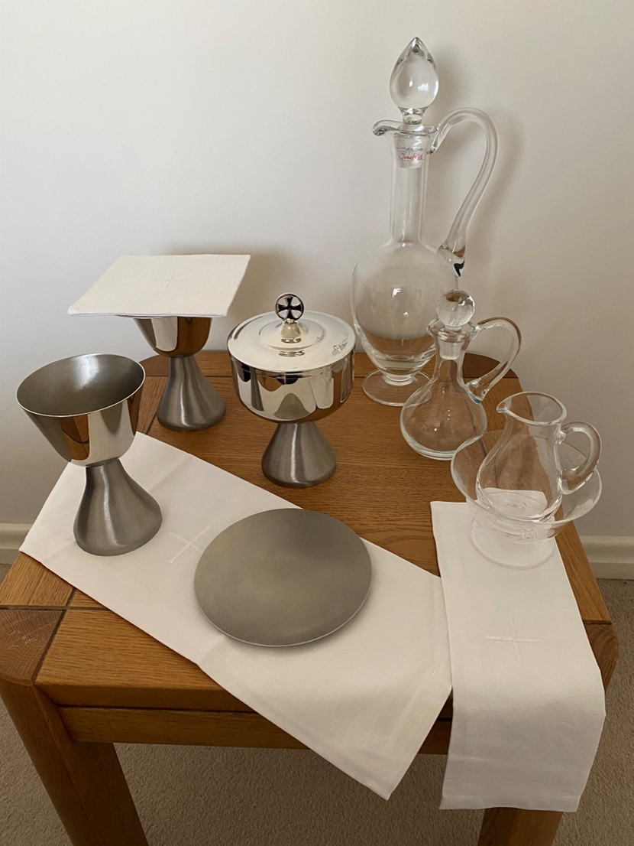
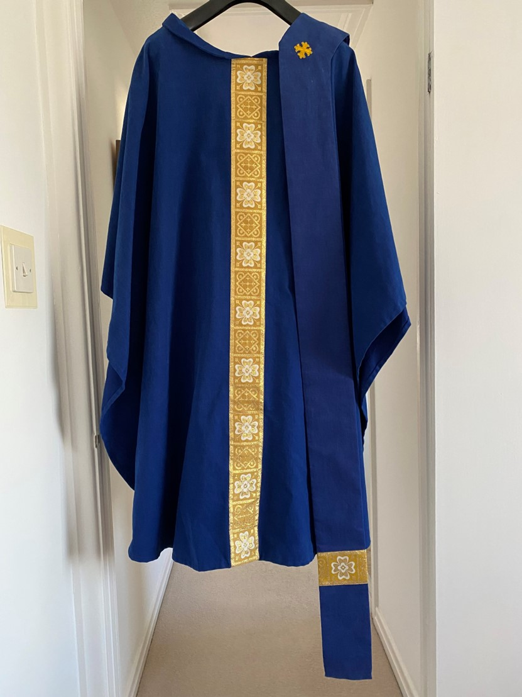

Two Chalices, two Pattens and a Ciborium, in brushed pewter, were purchased with donations from Jennifer Snowdon, Marion Thompson and Brenda Park in memory of their own mothers who were long-standing MU members. A bequest from a long-standing member of Shiremoor branch enabled MU to buy two crystal flagons, a crystal bowl and material for vestments. The pewter ware, crystal and blue material were sourced by chaplain Revd Allan Marks. The blue chasuble and stole were made by Dorothy Naylor, a friend of Pat Johnson, and were first worn and blessed by Bishop Martin in 2010. Chaplain Revd Marian Penfold gifted the embroidered corporal, covers and cloths.
The President’s brooch was given by Revd Malcolm and Mrs Audrey Trueman in the 1980’s. A folding altar bookstand was donated by Helen Brunton; also two oak banner stands were given to the Cathedral. Pat Johnson gifted an inscribed wooden cross, made by a woodworker at Kirkharle. Barbara Packer gifted a blue crystal bell for use at meetings.

