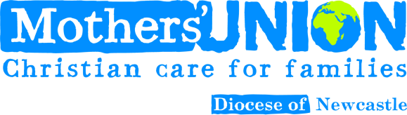 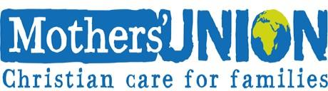

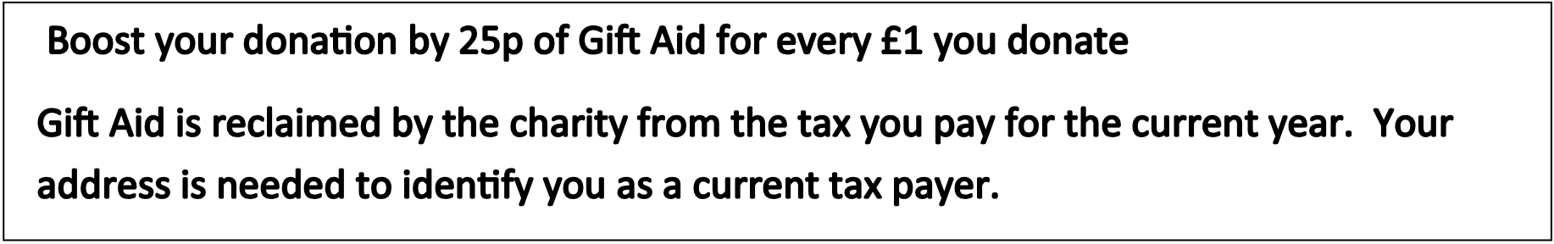Gift Aid Declaration

I want to Gift Aid any donations or qualifying subscriptions I make in the future or have made in the past 4 years to the Charity.

I am a UK taxpayer and understand that if I pay less income Tax or Capital Gains Tax than the amount of Gift Aid claimed on all my donations in that tax year it is my respon-sibility to pay the difference.

**My details**

Title ………………………………………………………………………………

First Name ……………………………………………………………………..

Surname ………………………………………………………………………..

Home address ………………………………………………………………….

…………………………………………………………………..

Postcode

Email

Signed

Date

……………………………………………………

…………………………………………………..

………..…………………………………………….. ………………………………………………………

Please notify us by phoning 07962 710045 if you:







want to cancel this declaration

Change your name or home address

No longer pay sufficient tax on your income and/or capital gains

**If you pay Income Tax at the higher or additional rate and want to receive the addi-**

**tional rate tax relief due to you, you must include all your Gift Aid donations on your Self-Assessment tax return or ask HM Revenue and Customs to adjust your tax code.**