**FLORAL TRIBUTE**

*Poetry can often express more than the most eloquent prose. Simon Armitage, the Poet Laureate, has written this tribute to Queen Elizabeth.*

**Floral Tribute**

**E**vening will come, however determined the late afternoon,

**L**imes and oaks in their last green flush, pearled in September mist.

**I** have conjured a lily to light these hours, a token of thanks,

**Z**ones and auras of soft glare framing the brilliant globes.

**A** promise made and kept for life – that was your gift –

**B**ecause of which, here is a gift in return, glovewort to some,

**E**ach shining bonnet guarded by stern lance-like leaves.

**T**he country loaded its whole self into your slender hands,

**H**ands that can rest, now, relieved of a century’s weight.

**E**vening has come. Rain on the black lochs and dark Munros.

**L**ily of the Valley, a namesake almost, a favourite flower

**I**nterlaced with your famous bouquets, the restrained

**Z**eal and forceful grace of its lanterns, each inflorescence

**A** silent bell disguising a singular voice. A blurred new day

**B**reaks uncrowned on remote peaks and public parks, and

**E**verything turns on these luminous petals and deep roots,

**T**his lily that thrives between spire and tree, whose brightness

**H**olds and glows beyond the life and border of its bloom.

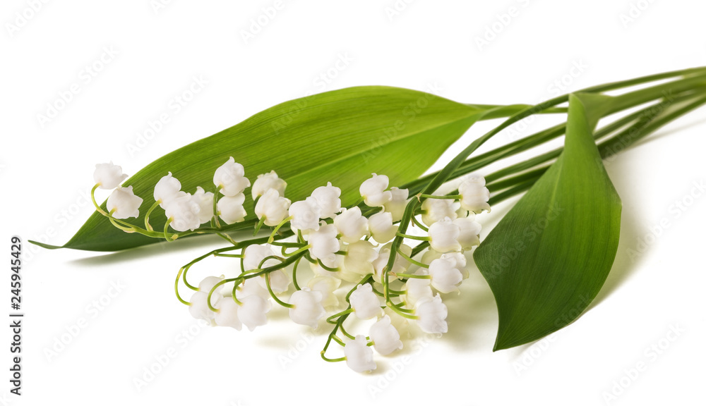

SIMON ARMITAGE  
Poet laureate