First Internet Branch
“Adopt a Refuge” Project

The branch delivered their first consignment in early March. They provided items for women and children who arrive at the Refuge with little or nothing. This initial delivery consisted of four of everything and will be topped up as and when required. The cost was covered by a grant from the Freemasons and will, hopefully, secure the project for at least a year, but Covid makes it difficult to estimate the turnover of people entering or leaving the Refuge.
The photos show a very small selection of items provided.

Sylvia Hickey. V.P.

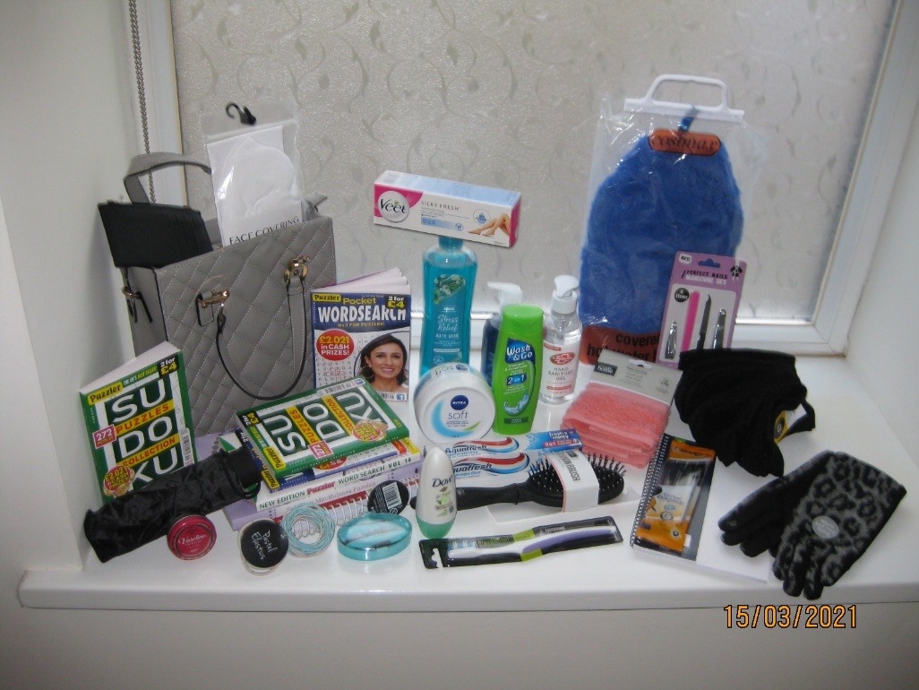
Womens items

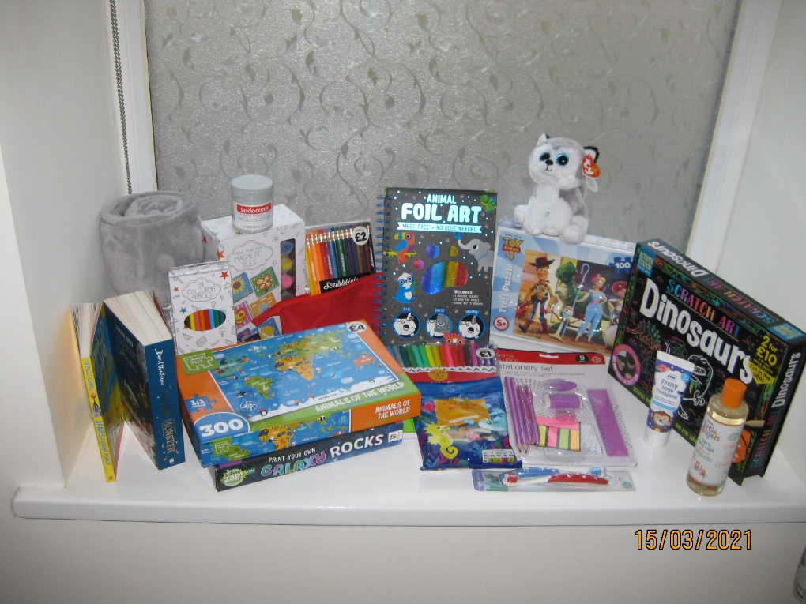
Kids stuff

