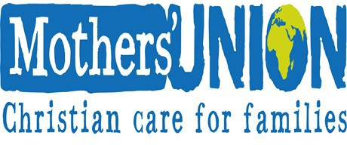 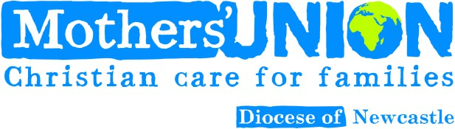

Please fill in the whole form using a pen and send it to Canon Barbara Packer

Devonshire House

Alma Place

Whitley Bay NE26 2EQ Member full name

Joint member name (if applicable)

MU Newcastle Membership

Instruction to your Bank or Building Society to pay by Direct Debit

Originator’s Service User Identification Number



Collection reference

Home postcode

Email address

# Membership type (please tick)

Name(s) of Account Holder(s)



# MU Branch or Group

Branch Sort Code

Branch/Building Society account number

Name and full postal address of your Bank or Building Society

**Instruction to your Bank or Building Society**

Please pay Mothers’ Union Direct Debits from the account detailed in the Instruction subject to the

safeguards assured by the Direct Debit Guarantee. I understand that the instruction may remain with Mothers’ Union and, if so, details will be passed electronically to my Bank/Building Society

|  |
| --- |
| Signature(s) |
|  |
| Telephone number |



Date (DD/MM/YYYY)

|  |
| --- |
| To: The Manager Bank/Building Society |
| Address |
|  |
| Postcode |

/ /

Bank or Building Societies may not accept Direct Debit instructions for some types of account



**The Direct Debit Guarantee**

This Guarantee is offered by all Banks and Building Societies that accept instructions to pay Direct Debits

* If there are any changes in the amount, date or frequency of your Direct Debit, Mothers’ Union will notify you 10 working days in advance of your account being debited or as otherwise agreed. If you request Mothers;’ Union to collect a payment, confirmation of the amount and date will be given to you at the time of the request.
* If an error is made in the payment of your Direct Debit, by Mothers’ Union or by your bank or building society you are entitled to a full and immediate refund of the amount paid from your bank or building society.
* If you receive a refund you are not entitled to, you must pay it back when Mothers’ Union asks you to.

You can cancel a Direct Debit at any time by simply contacting your bank or building society. Written confirmation may be required.

Please consider completing the Gift Aid declaration on the reverse