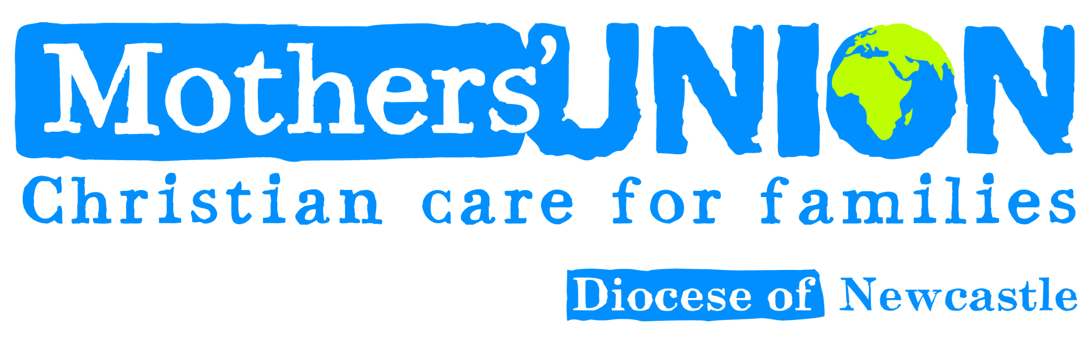
Diocesan Council Meeting
on Friday 14th October at 6.30pm in St John’s Kingston Park.
Refreshments served from 6.00pm

AGENDA
- President’s welcome.
- Opening worship led by our Chaplain, the Rev’d Anne Marr.
- Apologies.
4. Welcome to Members attending Council for the first time.
5. Minutes of the last meeting held on 8th April 2022 (attached).
- Matters Arising.
- President’s remarks
- Reports
a) Action & Outreach Diana Macnaughton
b) Faith & Policy Jackie Moore
c) Marketing & Communications Linda Benneworth
d) Safeguarding Sheila Walker
e) Diocesan Members Sylvia Hickey
f) Deanery Leaders
9. Any Other Business - 48 hours notice required.
There will be a presentation on Re-imagining MU followed by a short discussion.
Subscriptions for 2023: Individual £30, Family Membership £51.
Dates 2022
22nd October Diocesan Members Day at St Nicholas, S Gosforth.
10.30am for 11.00am. The MU Choir will sing. All welcome.
25th October Deadline for copy for Winter Journal.
1st December Midday Prayers in the Cathedral led by Rev’d Anne Marr.
16 days of activism.
2nd December Gift bag day at Church House 10.30am.
5th December Advent Service at Holy Saviour’s Tynemouth 2.00pm
5th December West Deanery Advent Praise at Holy Cross Fenham at 2.00pm
5th December Advent Service at Hexham Abbey 2.30pm.
12th December Advent Service St James’ Morpeth 2.00.
14th December Advent Service St Michael’s Alnwick 10.00am.
Dates 2023
2nd February Pay in Day at Cathedral.

The meeting will end with the Grace.

Please read and have available the Agenda and attached reports, which will not be read out at the meeting; but any questions will be answered. Please ensure that others attending Council also receive the papers.

All members are welcome to join us.

