**Best Kept Secrets: a trinity to challenge us**

*“Not everyone who says to me, ‘Lord, Lord,’ will enter the kingdom of heaven, but only the one who does the will of my Father who is in heaven.” Matt 7.21*

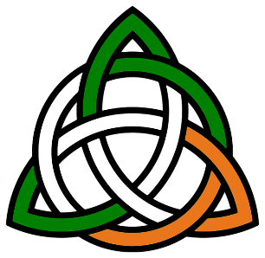Trinity is a time to celebrate those things we cannot quite grasp! Like the Trinity itself; and also the Church of England’s trinity of ‘best kept secrets’……

**.. the Mothers Union, the Church Army and the Diaconate.**

Ask anyone in your street – and it’s unlikely that they’ve heard of any of them. Even many church goers are unaware of their existence. They share a common purpose: to transform the lives of those they serve. Strangely, they are often undervalued and marginalised as agents of church life.

**The Diaconate** is seen as a probationary year to priesthood rather than a call to minister across the doorway of the church – bringing the needs of the world into the church and taking the love of Christ out into the world. Few people know of our life-long vocational deacons.

**The Church Army** *(as distinct from the Salvation Army)* is not simply a band of entertainers at beach missions, but specially trained, creative evangelists who work with people and in places of great need.

**The Mothers’ Union** is sometimes ‘mocked’ as the ‘Grand Mothers’ Union’ *(Yes – it IS a ‘Grand Union of Mothers’ and its ‘Grand-mothers’ are foundational in family life!)* MU has placed family life and the valuing of parenthood at the forefront of social welfare.

These three have a ‘ministry of transformation’. They are integral to the church, with **‘service’** as their common thread of identity, yet distinct in character and focus. Their work helps to profile social need, and they have forged many social reforms. They serve unobtrusively, unsung, amidst the everyday fabric of life, valuing ‘the ordinary’, ‘the lost’ and ‘the forgotten’ in society and transforming the lives of vulnerable people.

They are authorised reminders of the marginalised, and a sign of Christ the Servant, one person of the Holy Trinity, alive in our midst today. **Alleluia!**