Reflection - February 2021

My Dear Friends,

I hope you are keeping safe and well as we not only continue the fight against Covid, but against the severe weather conditions which are affecting parts of the world.

Here in the UK and Ireland this means ice and snow and low temperatures but in some parts of the world it means floods, fires, and extreme heat. There is of course one person who has control of all weather, and our lives, and that is God our heavenly Father. He loves us so much and is here to guide us in the right way, the way that leads to happiness and a better understanding of the way ahead.

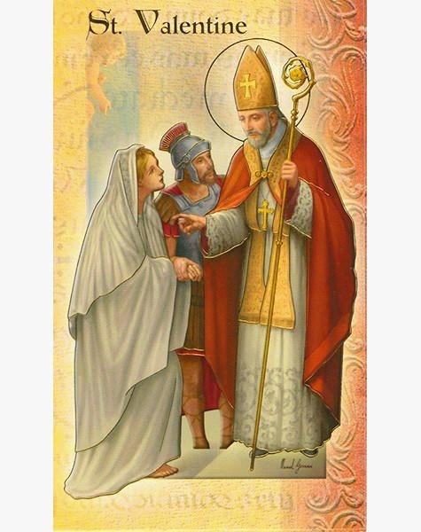
February is a month when we think and hear a lot about love, it is the month which contains St Valentine’s Day, when we especially remember those we love, sending cards and giving chocolates and flowers, very often red roses. But who was St Valentine? Well, we are told he was born in 226AD in Terri Italy and is said to have befriended his jailer’s daughter, healing her from blindness and sending her a letter signed ‘from your valentine’. [maybe this is where the saying ‘love is blind’ comes from] This was possibly how the act of sending letters and now cards to those we love came from.

Despite holding high office in the church, he seems to have been quite a rebel, but maybe a loveable rogue with a sense of humour.

For me 14th February holds mixed feelings as it was the day, when 13 years ago my husband died. He was a loving man but never considered he needed to celebrate Valentine’s day. Now it is a day when the family remember him with love and celebrate his life.

I am sure you have happy memories of someone you have loved but see no more. But our God and loving Father has hold of them, keeping them safe as he keeps us safe in his loving arms. We have a love in our lives which has been given as a gift from our heavenly Father, a love for the Mothers’ Union and its work. It’s what keeps us motivated even during these uncertain times. It what keeps us knitting and sewing for hospitals and collecting for food banks, it’s what keeps us making phone or video calls to MU friends, which at present we cannot see, but love and care for. I want us to be encouraged, to stand firm and strong in the Saviour’s love remembering that the most important thing we can do is pray, pray with love in our hearts, because God is love and without Him we can do nothing.

I would like to finish both with a prayer for St Valentine’s Day and some words written as a reminder of the work of the MU which is sung to the tune of, ‘We have a Gospel to Proclaim’, a tune we are all familiar with. You can go on to sing the hymn if that uplifts you as it does me.
Love & Prayers
Jenny



We have a purpose and an aim,
this Worldwide Mothers’ Union here,
a life in Christ we must proclaim
and Christian marriage hold most dear.

Five objects shown in word and deed,
Christ’s marriage teachings to uphold.
encouragement as parents lead
their children and the faith unfold.

A worldwide fellowship in God,
in union, worship, service, prayer,
so that a stable family life
Is given to every child we share.

Our help to those in deep distress
should be our everlasting theme,
so through the world our union press
to serve, to love, with Christ redeem.

