Action and Outreach Summer 2020

Things have obviously been very different for Action and Outreach since March. It was fortunate that we were able to have a craft session at “Walking With” before the lockdown. We took donations of clothes, bedding and toiletries when we ran the session. The centre has been closed since and we wait to see what will happen in the Autumn when it reopens.

AFIA breaks June 2020.
For those in refuges the past weeks in lockdown have been especially difficult. Now we are coming out of lockdown it is wonderful to be able to offer these families who are “really fed up” AFIA breaks. Margaret Crawforth has been working very hard with the refuges, caravan parks and other agencies to help provide holidays for vulnerable families. Several of these holidays are different from last year, as indeed they have to be but the aim is to salvage something during this summer to help create good lasting memories for as many people as possible. Two ladies have been accepted for a supported break at Shepherds’ Dene. North Tyneside refuge had asked if we could help fund some short breaks for their families and on Saturday 8th August the first two families went to stay in two caravans hired by Mothers’ Union for their two night stay. There will be regular exchanges until all fourteen families had had their short break away. The refuge hopes these short breaks will improve the wellbeing of those who have had a difficult few months.

Kathy Dunn and the group of twenty seven adults and thirty children from the Pendower Holiday Group left for their holiday at the Blue Dolphin Park in Filey, Yorkshire, at the end of July. This was the first holiday which Mothers’ Union had supported since the start of lockdown in March.

The group was from the Pendower Good Neighbour project. Because of social distancing rules, five cars, as well as the coach, were used for transport.

The children were so excited at the thought of going away after such a long time in lockdown. The families had saved up to pay for their own accommodation but needed help with the transport costs.

After the holiday the group sent Margaret Crawforth a “thank you” card for all her hard work because they had all enjoyed a wonderful break. They also thanked the members of the Mothers’ Union who had helped to make the holiday possible at such a difficult time.

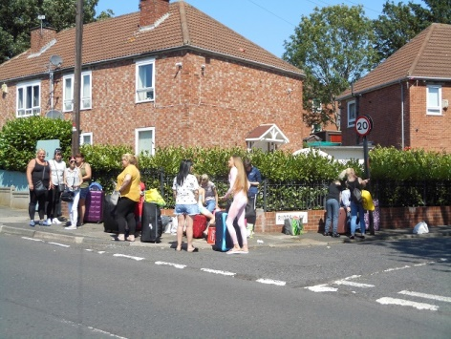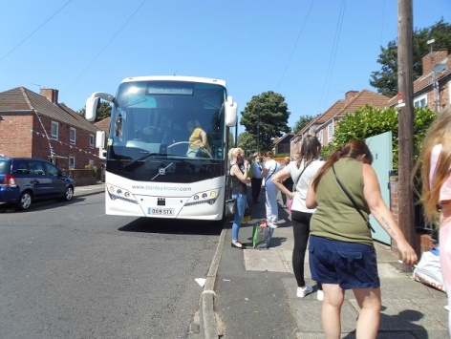

The photographs show the families waiting to go to Filey for their holidays
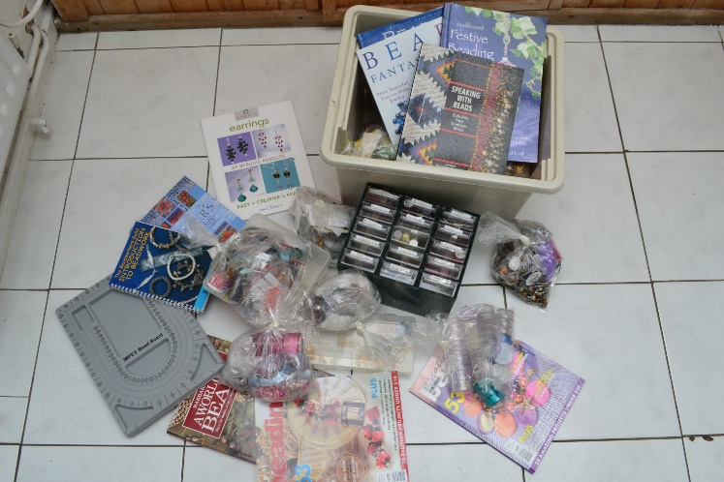
Craft Sessions.
We do not know when we will be able to offer craft sessions to women at "Walking With", "Changing Lives” and the women's refuges. When we can, we are now able to offer an even greater range of resources. Extremely generous donations like the one from Jen Merritt of Bardon Mill will help the ladies learn more about beading and will provide the materials needed to create original pieces. We are extremely grateful to Jen and look forward to seeing the finished work.
On behalf of all the ladies, thank you Jen"

Changing Lives.
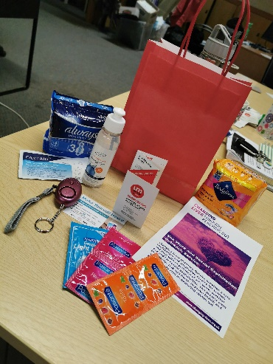
Since lockdown we have all become increasingly aware of the enormous increase in domestic abuse. Whilst we cannot have contact with clients at Changing Lives GAP we have been able to support them through the provision of personal alarms. We have bought 17 personal alarm with a keychain and Led flashlight as approved by the police as a self defence
panic rape attack device. These cost £130 and were the ones requested by GAP. They are included in the “safety Packs” which are issued to vulnerable women. One such pack is shown here.

This Autumn we plan to support the Inspire Project at a local Refuge. Mother’s Union will pay for the cost of room hire for 11 days to allow 67 women to complete the programme, in four groups. The cost will be approximately £770.

Christmas bags.
I have been in touch with The People’s Kitchen to find out if there have been any changes in their request for support this Christmas. They have asked for just over 100 shoe boxes. We are going to buy waterproof nylon drawstring bags and send these down to the kitchen separately. Gifts in the shoeboxes will then be able to go in these bags. Barbara has produced a list of what we hope each box will contain

The women’s refuges have requested gift bags again. Sylvia has produced a separate sheet to give members an idea of what each bag should contain. I suspect that throughout the year bags of toiletries and underwear will be in great demand as women leave the refuges and hostels.

We plan to continue supplying “Freshstart” backpacks for the newly released prisoners.

It would be good too sometime in the future to be able to resume some craft sessions for residents of refuges and hostels as well as refugees and asylum seekers.

At “Walking With” we would hope to continue to provide AFIA holidays and Away days. Although not possible this year we might even be able to arrange Santa Trips in the future.

Linda
Appendix: THE INSPIRE PROGRAMME
Purpose: The Inspire programme aims to empower attendees by increasing their awareness and understanding of what constitutes an abusive relationship. The traditional empowerment programmes for victims of domestic abuse have not been significantly updated in the past 20 years and yet our thinking and understanding about domestic abuse has altered considerably in this time. They tend to focus on physical behaviours and issues such as coercive control; online abuse and stalking do not feature in these programmes, yet they are major factors within abusive relationships in 2020.

Inspire looks closely at all aspects of domestic abuse including technology advancements and how these can be used to perpetrate abuse. It also covers changes in legislation, such as coercive control. We hope that by doing this we help to dispel myths surrounding relationships and encourage a wider range of clients to access the programme.

The attendees are encouraged to chart their journey by a variety of measures, which includes self-reflection. These will be used throughout to help them understand what changes have been made.

Marketing Report for Trustees and Council September 2020
This year has raised particular challenges in terms of keeping our members informed and engaged. It was clear by June that it would be inappropriate to ask Branch Leaders to deliver Journals to all members. Lesley Wright rose to the challenge by producing ‘Almost the Journal’, a 6-side emailed Newsletter, focussing on the ways in which members were supporting each other and providing support for the community. In order that all members could receive this, in colour, Branch Leaders were reminded that all expenses could be claimed. In addition, Joan Howard valiantly took on the task of printing and sending for those unable to access the facilities, and including some large print copies (total of 204 standard and 4 large print copies). Meanwhile Branch Leaders sent copies by email where possible, but also undertook a great deal of delivering and posting. September brings another Newsletter, just double-sided, with similar arrangements. We anticipate that the December issue will follow the same pattern, as ‘Almost the Journal’.

Meanwhile the July – December Families Worldwide was posted by Mary Sumner House to members individually where possible, using the database, and Jackie Moore took on the task of mailing it (along with the Appeal letter) to those who did not receive it. This was an important exercise, as a final FWW will be delivered in the same way this Autumn; and, from then on, all issues of the new publication and prayer diary, from 2021 onwards, will come through our letterboxes. It highlighted the importance of the database, which is as yet imperfect, since not all of Julian’s amendments have been implemented by the Mary Sumner House team, but we’re getting there! Please make sure that you send any amendments to members’ details to Julian Brown.
Many thanks to Margaret Weaver for her work on the website. Do remember to send her any news and photographs you have, so that our website can continue to be interesting, up-to-date and informative.

Thank you to all those who have worked so hard to enable members to receive up-to-date and encouraging news!

Barbara Packer

Faith & Policy Report
- 16 days of Activism Against Gender Violence takes place each year from 25th November – 10th December. Saturday 5th December has been named as The Global Day of Action, when members are asked to protest by demanding ‘no more 1 in 3’, the unacceptable global statistic. In Newcastle we plan to have a YouTube service, broadcasting live at 2pm. Prayer and action is important during this time.
- 2021 MU retreat is planned for Monday 31st May – Tuesday 1st June at Shepherds Dene. The retreat will be led by Jennie Jones and Malcolm Jones will join us on the 2nd day to celebrate The Eucharist.
- A group of Newcastle MU members join others in the UK to write prayers for 3 weeks, for Families Worldwide. In the current magazine we contributed to the weeks beginning 9th August – MU Family, 6th September – Learning and Sharing and 8th November – Memories.
- The Prayer Cycle led by Lorna Beadle is always active. At present there are 7 prayers with 25 people who have asked for prayers.
- Sylvia Hickey, myself and members throughout the UK attended a Zoom meeting with MSH. The meeting was from the Policy Community of Interest, with a focus on Domestic Abuse. At the inaugural meeting there were 2 main issues for discussion, the domestic abuse bill and plans for 16 days of activism.
- The domestic abuse bill is being discussed in parliament and we were informed about previous MU action and future plans to implement changes. Sylvia has sent out a template so that members can write to MPs.
- MSH have needed to amended plans for 16 days of Activism. Resources are available on line. 25th Nov 1st day of campaign starts with Morning prayers. 10th Dec last day of campaign ends with Evening prayers. Special midday prayers for the 16 days with guests from around the world to lead 5th Dec 11.30 meet for ‘no more 1 in 3’ Cup of Tea followed by midday prayers. 5th Dec on line protest and evening service.

Jackie

Finance & Central Services Report
Before the Covid lockdown I had a very positive, and very long conversation with Richard Miller the Finance Trustee, at Mary Sumner House, which was following a report and constructive critique of the Membership system I had sent to London. In that conversation, he invited me down to Mary Sumner House for a meeting, whilst also asking me to help to act as a consultant within the process on a National basis.

Once Covid struck, all was silence until on 21st July, I had a telephone call out of the blue, from Marian Pope, who on Emails calls herself the Membership Support Manager. She explained that we are in the top 3 Dioceses in the country for being organised in our approach to membership records, and that to date more than 1/3 have made no attempt whatsoever to reconcile their details and numbers either locally or nationally. After a constructive conversation, again, she assured me that this was her task going forward, she agreed that my data as a whole would be updated for me, en bloc, so I sent her a copy of my latest, revised spreadsheet for upload first thing the following day. I received an immediate response of thanks but since then silence....

Barbara has looked at the Database recently, but confirms that at that point, no changes had been made as a result of my work. Rather disappointing to say the least!
At the present time, I hold what is the nearest thing to a definitive detailed Membership Listing for Our Diocese, and would be happy to receive any amendments direct to me as soon as available, so as to avoid the pain of going through the whole process yet again.
I must also thank Sheila for helping me apply for and achieve a full clean enhanced CRB certification.

Julian
Marketing Report for Trustees and Council September 2020
This year has raised particular challenges in terms of keeping our members informed and engaged. It was clear by June that it would be inappropriate to ask Branch Leaders to deliver Journals to all members. Lesley Wright rose to the challenge by producing ‘Almost the Journal’, a 6-side emailed Newsletter, focussing on the ways in which members were supporting each other and providing support for the community. In order that all members could receive this, in colour, Branch Leaders were reminded that all expenses could be claimed. In addition, Joan Howard valiantly took on the task of printing and sending for those unable to access the facilities, and including some large print copies (total of 204 standard and 4 large print copies). Meanwhile Branch Leaders sent copies by email where possible, but also undertook a great deal of delivering and posting. September brings another Newsletter, just double-sided, with similar arrangements. We anticipate that the December issue will follow the same pattern, as ‘Almost the Journal’.

Meanwhile the July – December Families Worldwide was posted by Mary Sumner House to members individually where possible, using the database, and Jackie Moore took on the task of mailing it (along with the Appeal letter) to those who did not receive it. This was an important exercise, as a final FWW will be delivered in the same way this Autumn; and, from then on, all issues of the new publication and prayer diary, from 2021 onwards, will come through our letterboxes. It highlighted the importance of the database, which is as yet imperfect, since not all of Julian’s amendments have been implemented by the Mary Sumner House team, but we’re getting there! Please make sure that you send any amendments to members’ details to Julian Brown.

Many thanks to Margaret Weaver for her work on the website. Do remember to send her any news and photographs you have, so that our website can continue to be interesting, up-to-date and informative.

Thank you to all those who have worked so hard to enable members to receive up-to-date and encouraging news!

Barbara Packer
Diocesan Members Report
I have cancelled the Diocesan Meeting on 24th October as Corona Virus 19 is unpredictable. Unable to give you a date for Spring Meeting 2021 as yet.

Edna

