August Reflection
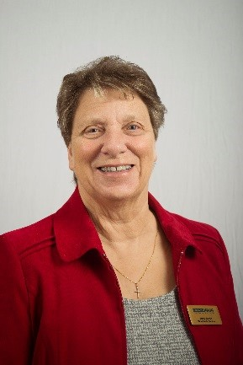
My Dear Friends,

Greetings in the name of our Lord Jesus, Christ. I do hope you feel as I do, that we are at last being allowed a little more freedom. Freedom to visit friends and family and have them visit us. It may still be in a ‘bubble’ or meeting outside, but just having human contact, for me, lifts the spirit.

Last month I received my first hug from my daughters and granddaughter since March. But life can be scary out there when you haven’t left home for so long. My daughter has suggested that she comes with me the first time I go to the big supermarket to enable me to regain my confidence; I am grateful for that support.

This month we celebrate Mary Sumner Day on the 9th August and we can certainly gain confidence if we follow in her footsteps. I am sure you remember that after she had called that first meeting of her friends and neighbours, she was so afraid, she was unable to lead the meeting and her husband had to help, by asking the ladies to return a week later. It took her a while to overcome her fear but once she did, look what the result was.

This organisation, despite the devastation this pandemic has caused, is still going, thanks in the main to Bev Julien, our CEO and her Senior Leadership Team, who continue to work long hours and take on extra tasks to enable us to benefit from, and help others to benefit from, the work which Mary Sumner began that time in the sitting room of the vicarage.

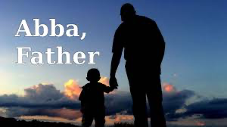
As Christians, we know that all this help and support comes from the love of God and this put me in mind of the modern hymn, which asks you to: - Put your hand in the hand of the man who stilled the water, put your hand in the hand of the man who calmed the sea. Take a look at yourself, and you can look at others differently, put your hand in the hand of the man from Galilee.

There are other verses, but if we can follow these guidelines, I feel sure we will all feel safe and uplifted.

I am also reminded that worship is….celebrating the presence and power of God’s Spirit. Let us then celebrate and give thanks that life is moving on, but let us not forget to keep praying for Bev and her team and all in our worldwide membership, together with all in our provinces, dioceses, deaneries and branches who have suffered and all whose life has been changed forever.

The team at Mary Sumner House have put lots of recourses on the website to help you celebrate Mary Sumner Day including an online service of Morning and Evening prayer. If you are able, please make use of these, even if the date has now passed, please do so and if you are fortunate enough to be able to join with others that day then may God bless you as you worship Him together.

I thought you might like this poem written by member The Revd Terry Roberts.

A Wave

Stretching as far as the eye can see
A blue ocean reflects the heavens
Still and calm it brings peace and tranquillity
The Wind of the Spirit moves over the deep
And waves begin to form
They stretch beyond the horizon
Across all the seas and oceans covering the world
Each wave made of millions of drops in motion.
Our prayers, like each drop in the ocean,
Cover the world;
Driven by the spirit they become waves
Touching the very fabric of God’s creation,
Bringing peace and tranquillity to situations, to conflict,
To our Souls

A Blessing
‘Rejoice in the Lord always!
Again I say, rejoice!
And the peace of God, which passes all understanding, will guard your hearts and minds in Christ Jesus.’

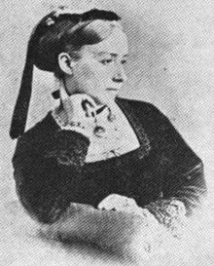

I wish you all a very happy
Mary Sumner Day
Love
Jenny

