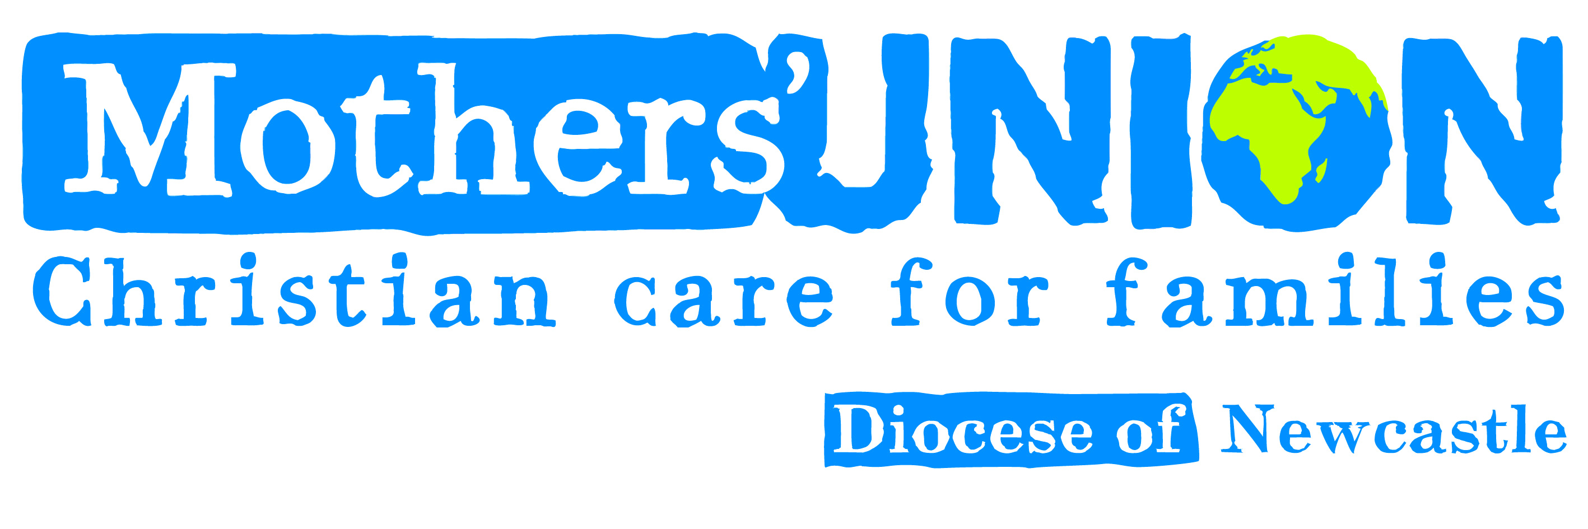

VISIT BY MARGARET SENTAMU TO HEXHAM ABBEY
MOTHERS’ UNION LINDISFARNE ARCHDEACONRY FESTIVAL

On Thursday 25th May Mrs Margaret Sentamu visited Hexham Abbey to speak at the Mothers’ Union Lindisfarne Archdeaconry Festival.
Mothers’ Union members from far and wide in Northumberland filled the Great Hall at Hexham Abbey for the talk in the morning.
Margaret Sentamu’s roots are in Uganda although she has lived and worked in the UK for most of her adult life. She is an independent diversity and leadership development consultant helping organisations to manage and engage with differences in the workplace. Previously she helped to select clergy for the Church of England. She is also a Non-executive director of the Leeds and York Mental Health Trust and Traidraft PLC, helping to fight poverty with fair trade. She is a Trustee and patron of a number of charities mainly to do with education, health and poverty in the Global South. She is married to the Archbishop of York.
Margaret started her presentation recounting stories from her early life and some of her amusing experiences as the wife of the Archbishop.
She then went on to discuss the theme of the book by Richard Rhor ‘Falling Upward into the Arms of God’ a spirituality for the two halves of life. She challenged us to reflect on our lives and how our experiences and ‘falls’ can lead us to greater spiritual growth in the second half of life, ‘The Saga Years’ as she called them. In the first half of life we need to be practical, get a job and write the script of our life but in the second half we have to own the script and have a wiser vision.
A very challenging concept which has left us with much to ponder!
In the afternoon we had a Mothers’ Union Festival Eucharist for Ascension Day, a truly uplifting and joyful Service, which began with a parade of banners from branches in the Archdeaconry, the like of which the Abbey had not seen before! The recently re-formed and enlarged Mothers’ Union choir led us in worship, it was their first outing, and they were much appreciated. Mothers’ Union members led the intercessions and stewarded the large number of people present. The Rev’d Matthew Hunter prepared the service and presided at the Eucharist. Our own Chaplain Rev’d Jane Scott was the preacher and she left us with the message to go out and do some good to our neighbour.
A very fitting end to a very special time of fellowship when the sun shone all day and we felt the presence of God all around us.
Sheila Walker
VP Lindisfarne Archdeaconry, Mothers’Union

