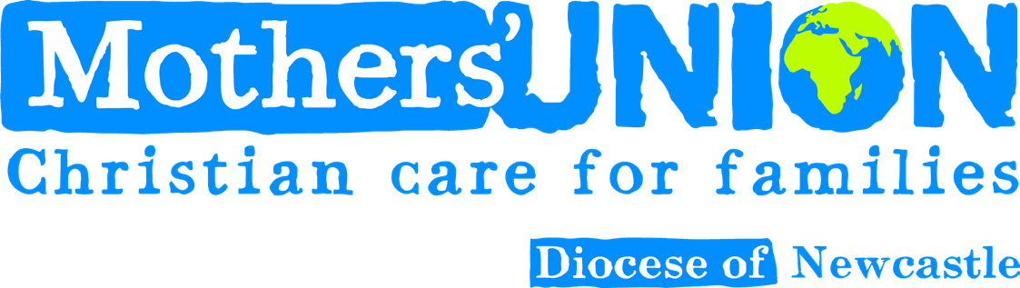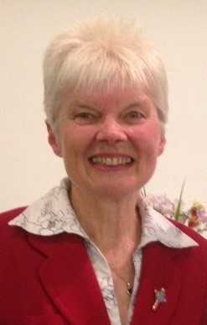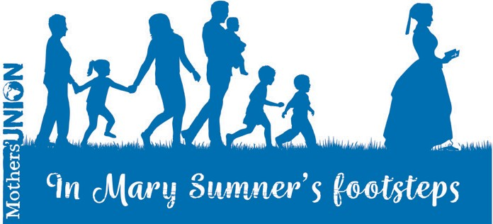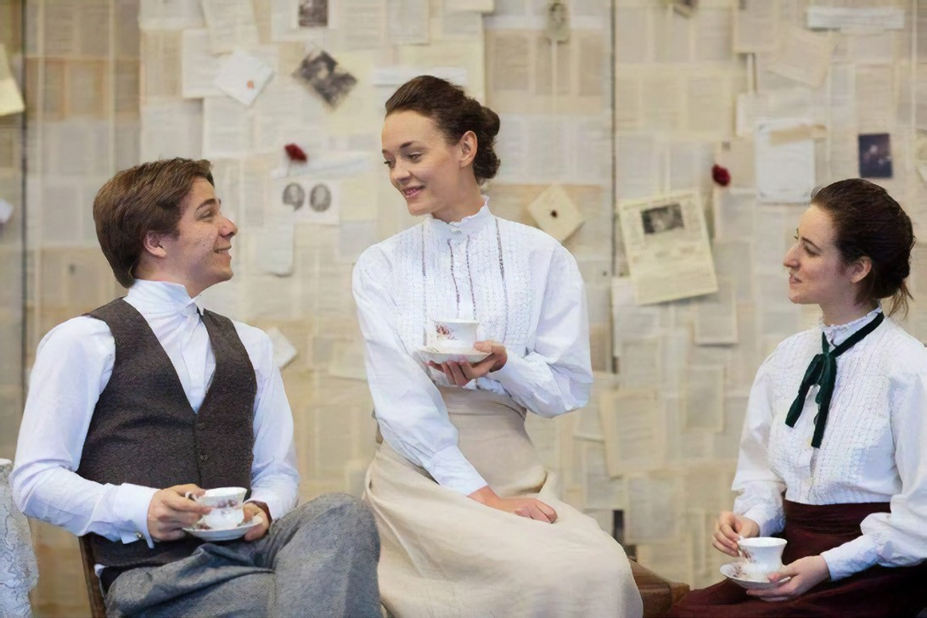

Saltmine Theatre Company Presents

**CHOSEN**

a beautiful production telling the story of Mothers’ Union founder Mary Sumner

Friday 12th October 2018 8pm

Christ Church, Preston Road, North Shields.

NE29 0LW

Tickets £5 each and are available on the door.

This performance can be enjoyed by congregation and local community.

Why not visit a restaurant in nearby Tynemouth before enjoying this splendid production.

Deaneries/ Branches might consider booking a coach, parking is available

*For more information see your MU Branch Leader or contact Lynne Craggs*

[*email lynnecraggs@hotmail.com,*](mailto:lynnecraggs@hotmail.com) *phone 01670 355411.*

**From the Diocesan President**

Dear fellow-member,

As we continue to celebrate this year’s theme ‘In Mary Sumner’s Footsteps’, it is a huge privilege to be one of the few Dioceses to host the very engaging play about her life, ‘Chosen’, performed by the Saltmine Theatre Company. I hope you will try to come to see it, as well as to

attend Diocesan Council, and that, *Canon*

where possible, transport will be *Barbara Packer*

arranged by Deaneries. As we come to the end of this Triennium, our Council meeting will celebrate the work of those stepping down, and introduce

newly-elected officers. Please pray for them, and also consider whether you might take on a new role next year: there are still vacancies to fill at every level.

**Families First**

Families First is being re-launched as a quarterly

‘members only’ magazine. The content will change to be more member-focussed, and the new price will be £10 per year. You will now need to order it directly from Mary Sumner House, and there is an order

form included in the September/ October edition of Families First, which you should just have received. PLEASE MAKE SURE YOU DO THIS – or you will not receive Families First next year! Perhaps you can talk about it in your Branch, so that no-one misses out. It is also a good opportunity for more members to start, and Branch Leaders will have spare order forms.

**Cathedral Service Days and Midday Prayers**

Staff at the Cathedral have been very grateful for

our work and worship at the Cathedral each month over the years, but it now seems the right time to discontinue this: the last Service Day will be on Thursday 6th December - do come if you can - there will be a cake! We will also celebrate the 16 Days of Activism against Gender-based violence. Canon Clare is keen to find other ways in which Cathedral and Mothers’ Union can work together: watch this space!

*Barbara*

**Newsletter *October 2018***

**DECEMBER**

**3rd 3rd 4th 6th 7th**

**NOVEMBER**

**1st**

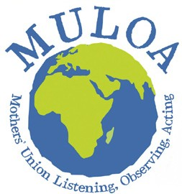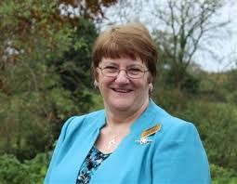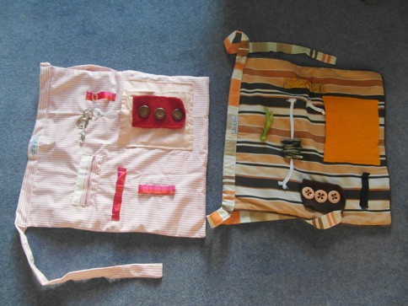

**Can you help?**

As we prepare for longer winter evenings, I wonder if any members or friends would be prepared to make” Activity Aprons” or “Twiddle Muffs” for those with dementia. We have received so many requests for these from residential homes. I am happy to send further details. Please help if you can. “Glad bags” would also be most welcome.

Thanks, Linda Benneworth *(lindabenneworth@sky.com)*

**Lynne Tembey, This is Your Life!**

Lynne Tembey’s final MU General Meeting finished with her being the subject of **“This is Your Life as Worldwide President”**

We enjoyed pictures and stories of all she has done, and meant to people over these past six years. There were amusing anecdotes too, not least from her husband, but the overriding feeling we were left with was how much she is loved and how much her work has been appreciated all over the world. Enjoy your retirement Lynne!

**M.U. Provincial Celebration Service**

for the end of the Triennium at York Minster on Friday 9th November at 11 a.m. with Archbishop Sentamu.

Our choir will be singing! No ticket needed, but please tell your Branch Leader, as we need numbers. We will make our own way by train.

**MU Journal Deadline**

The closing deadline for content for the MU Journal is Monday 15th October 2018. I am sure all branches will have enjoyed many activities this summer, please email your photographs with a write up to [lynnecraggs@hotmail.com](mailto:lynnecraggs@hotmail.com)

**2019 Theme**

Our new theme has just been announced: it is **‘Listen, Observe and Act - in step with God’**

This reflects the MULOA theme! Please include a MULOA conversation in your 2019 programme!

**Calendar of Events**

**OCTOBER**

**4th 4th 6th**

**Service Day & Midday Prayers:** Bedlington Faith and Policy Meeting 10.30am

Friends’ of Newcastle Diocese Mothers’ Union Meeting, Church House, 10am

Hexham & Bellingham Deanery: Coffee Morning with many stalls, Bardon Mill Village Hall, 10am - 12pm

**Diocesan Council** at **Christ Church, North Shields**

6.30 p.m. Tea/ coffee, 7 p.m. Diocesan Council 8 - 9 p.m. Production of ‘Chosen’

**6th**

**12th**

**Service Day & Midday Prayers:** Trustees followed by Action & Outreach meeting

16 Days of activism against gender-based violence

**25th-10th**

West Deanery: Advent Praise in Holy Cross Church, Fenham, 11am

Hexham & Bellingham Deanery: Advent Service in Holy Cross, Haltwhistle, 2.15pm Trustee Training Day, Carlisle Tithe Barn

**Service Day & Midday Prayers:** Faith & Policy Unit

**Coffee Morning** at Church House 10.30-12noon Shoe Box Day and collection of Journals. Please come along with your boxes.

Tynemouth Deanery: Advent Carol Service in St Alban’s Church Earsdon at 2pm Morpeth Deanery: Advent Carol Service, St James’s Church, Morpeth, 7pm

Newcastle East Deanery: Advent and Branch closing Service, St Mary Magdalene, Longbenton, 2pm

**10th 10th 12th**

**Contact Details**

w[: www.munewcastle.org.uk](http://www.munewcastle.org.uk/)

**Marketing Coordinator:**

Lynne Craggs

[e: lynnecraggs@hotmail.com](mailto:lynnecraggs@hotmail.com) m: 07792 190247

**Newsletter Coordinator:**

Daniel Doran

[e: hello@dandoran.uk](mailto:hello@dandoran.uk) m: 07954415253

**Diocesan President:**

Barbara Packer

[E: bppacker@googlemail.com](mailto:bppacker@googlemail.com) T: 0191 253 4321